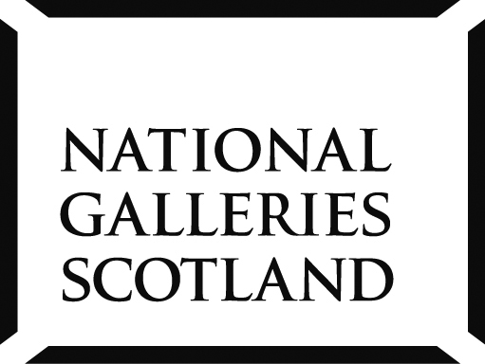
National Galleries of Scotland
Work experience application

Thank you for your interest in work experience with the National Galleries of Scotland.

IMPORTANT INFORMATION
- Our work experience placements do not have any direct involvement with the Art or exhibitions, but instead focus on the areas that support the running of a Gallery (fundraising, visitor services, education, retail, etc.)
- We receive a high volume of applications for the limited number of places available each year which means we cannot involve all students who express interest.
- If your application is taken forward, there will be a short informal interview (by telephone or in person).
Please submit your application to volunteer@nationalgalleries.org.
You must CC: a parent/teacher who should reply by email confirming their agreement to your request

Name: |  | DOB:
Home Address:
Email address: |  | Telephone:
Name of school:
Do you have specific dates for your work experience or are they flexible?
What is the deadline by which time you need to know if you have been accepted for a work experience placement?
1) What subjects are you studying at school?
2) What are your hopes for when you leave school? (type of work, areas of further study, etc.)

3) Why do you want to do your work experience with the National Galleries of Scotland?

4) Are you interested in a particular artist, time period, or genre of Art and why?

5) What do you hope to learn from your work experience?

6) Do you have any support needs or health concerns that we should be aware of for your own health and safety or the health and safety of others?

