Teachers’ Notes

Scotland and chattel slavery through the lens of art
edinburghartfestival.com
nationalgalleries.org

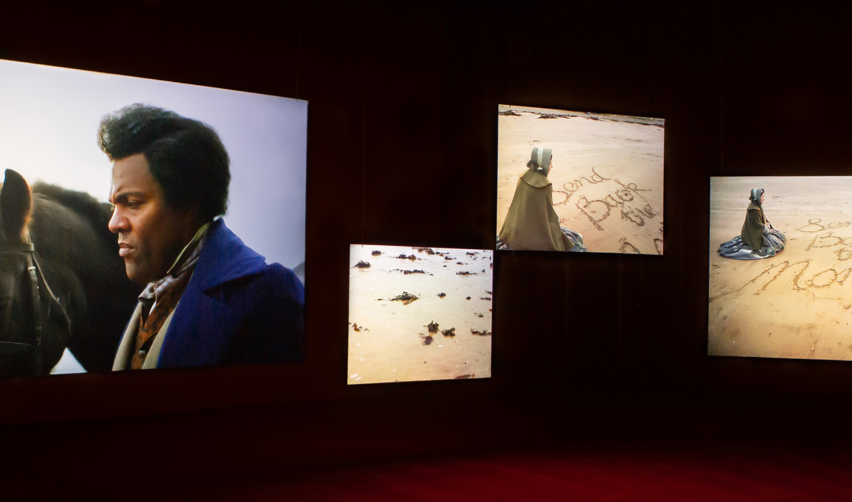

Introduction 3
Learning outcomes 4
Scotland and chattel slavery
Who is Frederick Douglass 5
Human Rights Activists 6
Quotes 11
The power of imagery to change society 12
Activities
Take a closer look 13
How to get to know something that cannot speak? 14
Lessons of the Hour 16
Glossary 18
Useful links 19

This resource is inspired by the artwork
Lessons of the Hour by Isaac Julien. His artwork is informed by research on chattel slavery, and in particular the life of formerly enslaved, influential anti-slavery activist and philosopher Frederick Douglass.
Scotland’s past, present and future have been shaped by chattel slavery, which persecuted millions of Black people. Art is used in this resource to investigate the impacts of chattel slavery on Scotland today.
Interdisciplinary learning activities are suggested to help learners discuss, research and investigate this subject matter.
National Galleries of Scotland and Edinburgh Art Festival are committed to equality, diversity, access and inclusion. This series of resources will continue to evolve through the input of educators, artists, creatives, teachers and learners.
We would love to share young people’s art related to this theme. If you’d like to have examples of your pupils’ art shared in an online gallery, please send photos to learning@ nationalgalleries.org

Introduction video
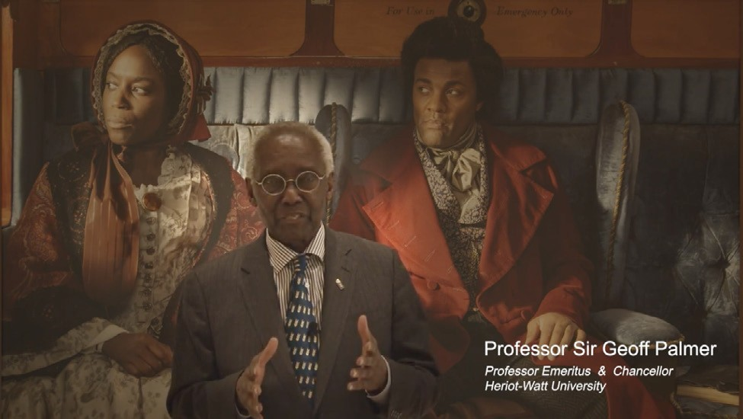
The introduction video features Sir Geoff Palmer: https://youtu.be/xCISgyxlzVk

Key Facts:
Suitable for: secondary school pupils (aged 11+ years)
Subjects: History, Modern Studies, Art and Design
Timing: adapt activities to suit, from one lesson to longer pupil-led projects
Disclaimer: Please note the links provided in this document were correct at the time of writing. Please refer to the web pages for up to date links.

This video features a painting of Robert Cunninghame Graham of Gartmore (1735- 1797) by Sir Henry Raeburn in about 1794. He was a poet, politician and Rector of Glasgow University who began his career in the slave economy of Jamaica. Raeburn’s portrait shows him as a literary gentleman, conscious of his status as a landowner and politician, but gives no hint that his wealth depended on the labour of enslaved Africans.
Professor Sir Geoff Palmer profile: http:// uncover-ed.org/geoff-palmer/
Interview Don’t take down the statues, take down the racism https://www.youtube.com/ watch?v=6hJSez661yg (2 mins)
Hear him on Scotland and slavery: https://www. youtube.com/watch?v=hrFZ-5XWsTQ (10 mins)
https://www.nationalgalleries.org/art-and- artists/features/scotland-and-chattel-slavery- through-lens-art

Relevant Social Studies Experiences
This resource aims to:
- raise awareness of Scotland’s colonial history
- raise awareness of how slavery continues to impact society today
- raise awareness of how art can reflect social issues and how we can make change in society
- provide a safe context in which young people can express opinions and discuss difficult issues
- encourage creative and critical thinking
and Outcomes

develop my understanding of the history, heritage and culture of Scotland, and an appreciation of my local and national heritage within the world
broaden my understanding of the world by learning about human activities and achievements in the past and present
develop my understanding of my own values, beliefs and cultures and those of others
develop my understanding of the principles of democracy and citizenship through experience of critical and independent thinking
explore and evaluate different types of sources and evidence
learn how to locate, explore and link periods, people and events in time and place

Relevant Expressive Arts Experiences and Outcomes
experience the inspiration and power of the arts
recognise and nurture my creative and aesthetic talents
deepen my understanding of culture in Scotland and the wider world
Having chosen personal themes and developed my own ideas from a range of stimuli, I can express and communicate my ideas, thoughts and feelings through 2D and 3D work.

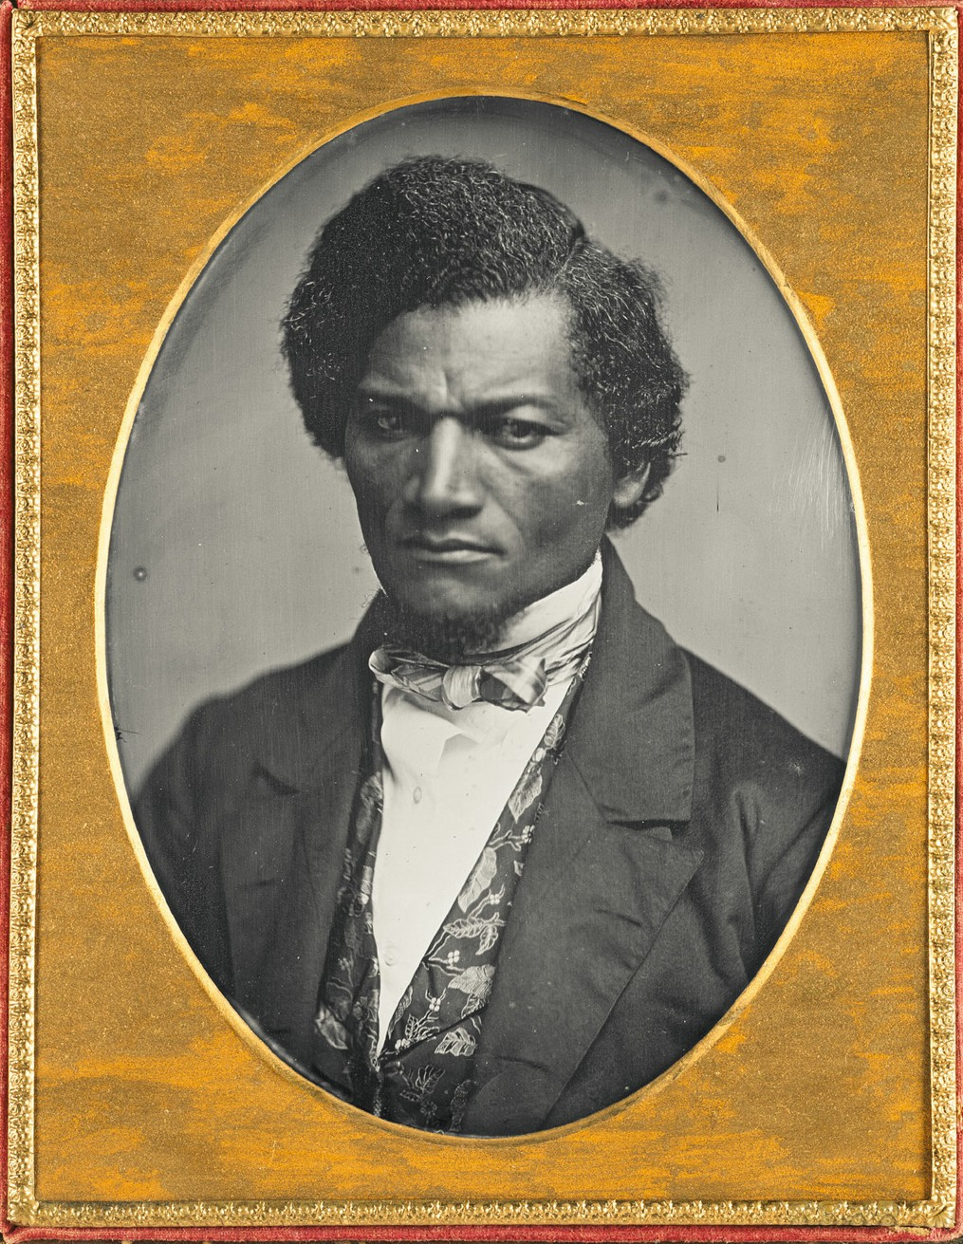
Who is Frederick Douglass?
Born Frederick Bailey (1818-1895), he was an American social reformer, abolitionist, orator, writer, and statesman. After escaping from chattel slavery in Maryland, he became a national leader of the abolitionist movement in Massachusetts and New York, becoming famous for his speeches and antislavery writings. He adopted the Scottish surname Douglass when visiting Scotland in the 1840s, his change of name corresponding with a change of identity from Frederick Bailey the slave to Frederick Douglass the free man.
In 1845, Douglass made a life-changing choice to publish the autobiography of his time in enslavement, titled The Narrative of the Life
of Frederick Douglass. The narrative resulted in both great success and great danger for Douglass and his family, because the book used real names and places and could have led to his recapture. To avoid this, Douglass
moved his family to New York then went abroad for two years. He made anti slavery tours of Scotland between 1846-1847 and 1859-1860.
Lesson suggestion
You may want to introduce Douglass in the context of other abolitionists and/or a wider context of human rights activists.
For example, parallels could be made with a contemporary figure that your students already know, such as Marcus Rashford, to help learners understand the comparable role played by Douglass.
E.g. ask your students to do their own research to find out about activists in Scotland, America or world-wide. Ask students to create a timeline and/or a world map pinpointing activists, where and when they were active.
On the following page are just some suggestions of human rights activists who fought for different causes. Some activists may have more than one cause and there are intersectional links between the legacies of chattel slavery and the discrimination, racism and poverty experienced by People of Colour in Scotland today.
Frederick Douglass is credited with having helped establish the civil rights movement in America. He believed in equal rights for everybody and used his writing, speeches
and political activities to fight for the rights of African Americans, women and others.
National Library of Scotland provide this brief summary of his life: https://www.nls.uk/ exhibitions/treasures/frederick-douglass/

Human Rights Activists
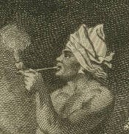
Joseph Chatoyer, also known as Satuye (died 14 March 1795), was a Carib chief who led a revolt against the British colonial government of Saint Vincent in 1795. Killed that year, he is now considered a national hero.

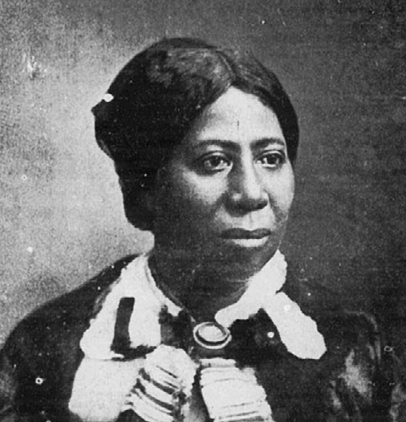
Anna Murray Douglass (1813-1882) was an American philosopher, orator and freedom fighter. Unlike her seven older brothers and sisters, who were born into chattel slavery, Anna Murray and her four younger siblings were born free, her parents having been manumitted just a month before her birth. She established a headquarters for the Underground Railroad from her home, providing food and board for fugitive slaves on their way to Canada. She helped Frederick Douglass escape from enslavement and later became his wife.

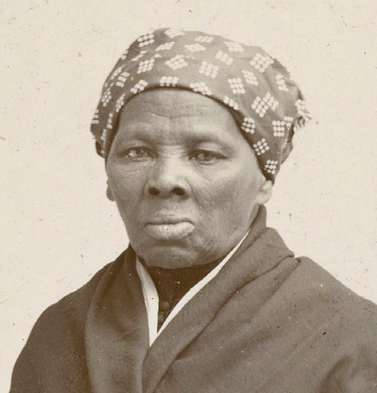
Harriet Tubman (approx.1815-1913). Born into slavery in America, Tubman escaped and subsequently made some 13 missions to rescue approximately 70 enslaved people, including family and friends, using the network of antislavery activists and safe houses known as the Underground Railroad.

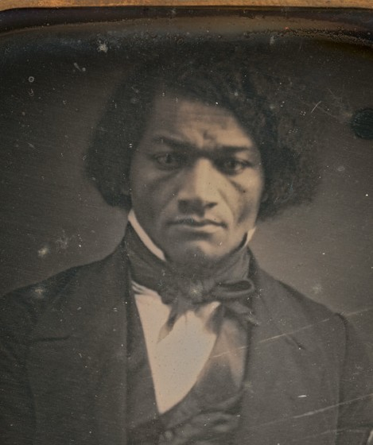
Frederick Douglass (1818-1895. Born Frederick Bailey). American social reformer, abolitionist, orator, writer, and statesman. After escaping from chattel slavery in Maryland, he became a national leader of the abolitionist movement in Massachusetts and New York, becoming famous for his speeches and antislavery writings. He adopted the Scottish surname Douglass when visiting Scotland in the 1840s,
his change of name corresponding with a change of identity from Frederick Bailey the slave to Frederick Douglass the free man. Douglass campaigned for more than abolition. For example, he was an early supporter of the suffrage movement.

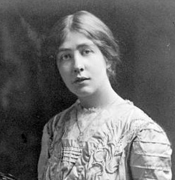
Estelle Sylvia Pankhurst (1882–1960) daughter of Emmeline Pankhurst, was an English campaigner for the suffrage movement, as well as a socialist and active anti-fascist. She was a promising artist but gave up art to focus on the suffrage movement. She created murals, designs and banners to support the cause.

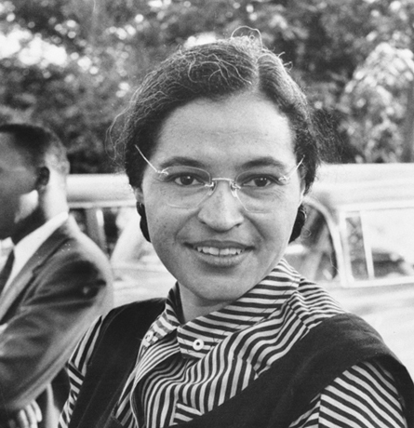
Rosa Parks (1913-2005). Rosa is renowned for having refused to give her seat to a white passenger on a segregated bus in Montgomery, on 1 December 1955. She was arrested for violating the Alabama segregation laws of the time which led to the Black community boycotting
Montgomery buses for over a year. This resulted in a decision in 1956 that bus segregation was unconstitutional.

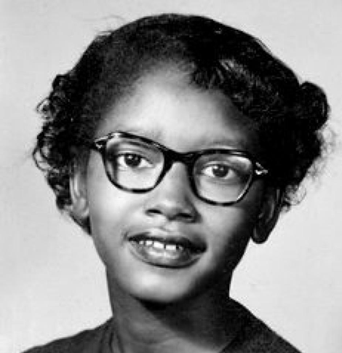
Claudette Colvin (1939-unknown) is a lesser-known figure who preceded Rosa in refusing to give her seat to a white passenger on 2 March 1955, when she was 15 years old.

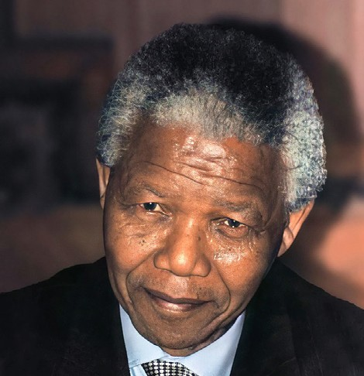
Nelson Mandela (1918-2013). South African anti-apartheid revolutionary, statesman and philanthropist who served as President of South Africa from 1994-1999. He was the country’s first Black head of state and the first elected in a fully democratic election.

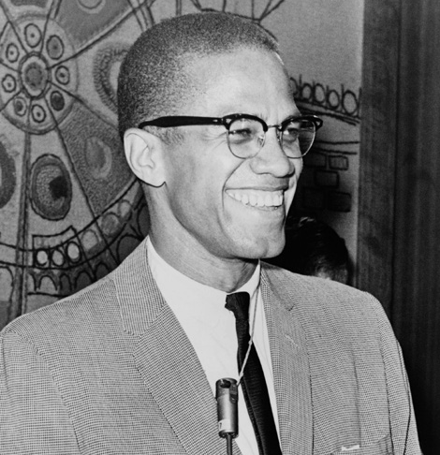
Malcolm X (1925-1965) was an African-American Muslim minister and human rights activist who was a popular but controversial figure during the civil rights movement. He advocated for Black empowerment, Black Separatism and criticised the main civil rights movement for its focus on nonviolence and integration of Black and white people. He was a
spokesperson for the Nation of Islam and later Sunni Islam prior to being assassinated.

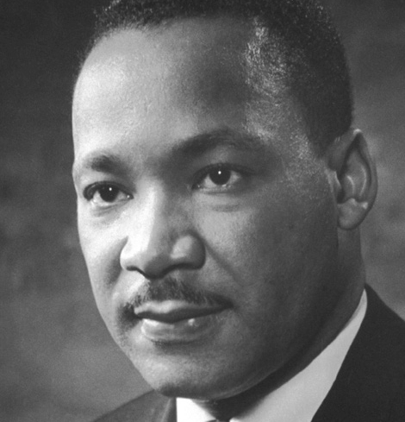
Martin Luther King (1929-1968) was an American Baptist minister and activist who became the most visible spokesperson and leader in the American civil rights movement from 1955 until his assassination in 1968. In 1963 he delivered his ‘I have a dream’ speech in Washington which outlined his dream of equality and freedom, calling for civil and economic rights and an end to racism. This speech is widely ranked as one of the most important in American history.

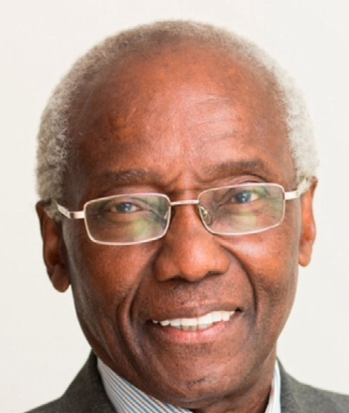
Sir Geoff Palmer OBE (born 1940) became the first Black professor in Scotland, at Heriot-Watt University in 1989 where he is currently
Professor Emeritus in the School of Life Sciences and also, as of 2021, the Chancellor. He is also a human rights activist and Honorary President of Edinburgh and Lothians Regional Equality Council, an organisation which works to tackle discrimination and promote human rights and equality, specifically with regard to the nine protected characteristics. Palmer led the movement to reinterpret the Henry Dundas memorial in Edinburgh, resulting in new signage which acknowledges Dundas’s role in delaying the abolition of slavery.

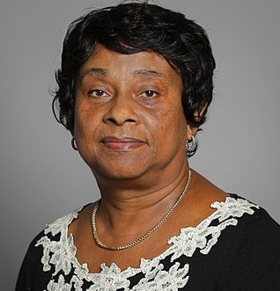
Doreen Lawrence OBE (born 1952) is a British Jamaican has campaigned for an inclusive society and for police reform in the UK. Her teenage son Stephen Lawrence was murdered in a racist attack in 1993.

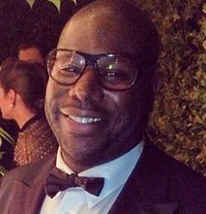
Steve McQueen (born 1969) is a British filmmaker and Turner-prize winning artist, renowned for a number of films including the award- winning 12 Years a Slave (2013), based on abolitionist Solomon Northup’s memoirs of the same name. In 2020, he explored the lives of London’s West Indian community from the 1960s-1980s in a collection of five films titled Small Axe.

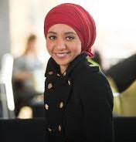
Amal Azzudin (born 1990) is an Egyptian-Scottish campaigner and a founding member of the Glasgow Girls; seven young women from
Drumchapel High School who campaigned against dawn raids and the detention of refugees, following the detention of a friend. Amal went on to work with refugees as Equality and Human Rights Officer for the Mental Health Foundation in Scotland.

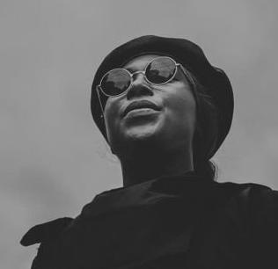
Sasha Johnson (born 1993/4) is a British activist who led a Black Lives Matter protest in London in 2020. She also launched the Taking the Initiative Party, in 2020, which she describes as the first black-led political party in the UK. While at a party in 2021 she was shot in the head. There is currently speculation about whether she was deliberately targeted or whether it was an accidental shooting.

Marcus Rashford MBE (born 1997) is an English footballer who campaigns against racism, child hunger and homelessness. In 2021, Rashford initiated a campaign to end child food poverty in England. Street artist Akse painted a mural of him in Manchester.

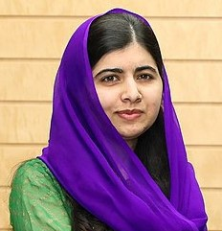
Malala Yousafzai (born 1997) often referred to as Malala, the youngest recipient of the Nobel Prize, is a Pakistani activist renowned for her human rights work. She has advocated for the education of women and girls in her home in northwest Pakistan, where the local Taliban has sometimes banned girls from attending school.

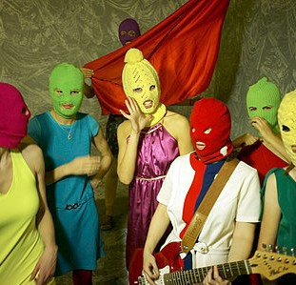
Pussy Riot (founded 2011) is a Russian punk rock group with a varying membership of approximately 11 women. They have staged provocative, unauthorised performances featuring lyrics which cover feminism, LGBTQ+ rights and opposition to the Russian President Vladimir Putin.

Why did Ross Blair paint Frederick Douglass on this wall in Gilmore Place, Edinburgh?

The murder of George Floyd by an American police officer in 2020 sparked international support for the Black Lives Matter movement, which had started in 2013 in the USA to fight racism and particularly, police brutality. In Scotland, one of the ways that support was shown for the movement was through the creation of the Black Lives Matter Mural Trail instigated by Wezi Mhura. There are at least 17 murals across Edinburgh, and others across Scotland, created by Artists of Colour, as visual symbols of solidarity.
One of these murals, painted by Ross Blair on Gilmore Place, depicts emancipated slave
Frederick Douglass who made anti-slavery tours of Scotland between 1846-1847 and 1859- 1860. He stayed at 33 Gilmore Place during his time in Edinburgh and gave over 70 speeches across Scotland promoting the abolition of chattel slavery. His words still resonate today for their relevance to the Black Lives Matter campaign. He recognised the power of images to communicate ideas and the power of the photograph to democratise society, making art accessible to the masses.
Find out more about the mural trail: https:// www.eca.ed.ac.uk/news/spotlight-onthe-black- lives-matter-mural-trail

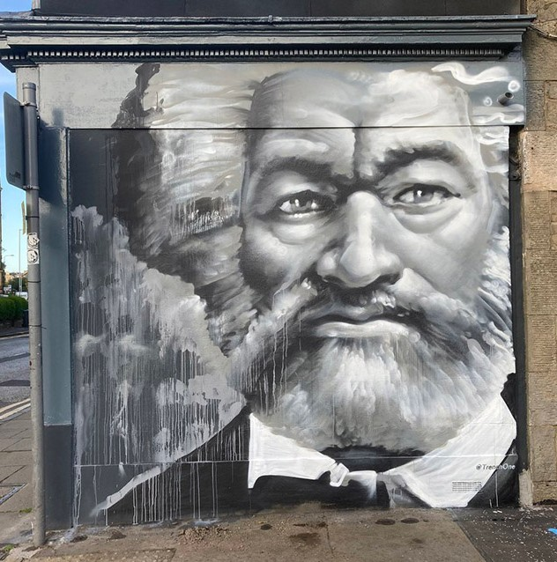
Image: Ross Blair aka Trench One, Frederick Douglass 33 Gilmore Place,
© Ross Blair

Quotes
Choose one of the following quotes by Frederick Douglass.
What does it tell you about him?

‘Send back the blood-stained money’
29 January 1846, Dundee
This was a slogan used by Douglass when he toured Scotland. The Free Church of Scotland had profited from the transatlantic trade in enslaved Africans and Douglass campaigned for this money to be returned. Despite his activism, the ‘blood-stained money’ was never sent back.
When chattel slavery was abolished, Scottish and UK slave owners were compensated for the loss of their ‘property’ but the emancipated slaves received no compensation.

‘I am here to speak for those who cannot speak for themselves and plead the cause of the perishing slave.’
12 February 1846, Arbroath
Douglass was committed to equal rights for all people of all nations and was a dedicated humanitarian. He never forgot his family members who died in slavery, and used his
own freedom to travel widely, giving speeches about slavery.
His concern was not only for people who were enslaved but much more generally for those who endured poverty and injustice. For example, he lent his support to the women’s suffrage movement early on, and he believed that women and men should have equal civil rights.

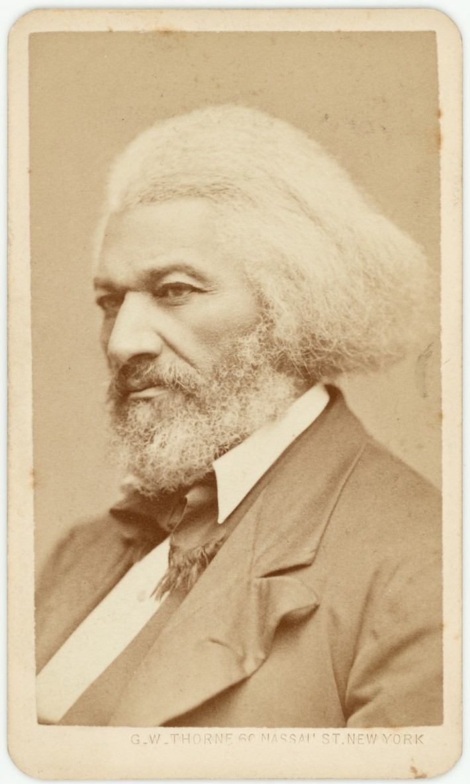

‘It is evident that the great cheapness and universality of pictures must exert a powerful, though silent, influence upon the ideas and sentiment of present and future generations.’
Lecture on Pictures, Boston, 3 December 1861
Douglass recognised that the invention of photography allowed the creation of images that would last for generations. Everybody could now afford to have their portrait captured, whereas previously, portraiture had been available only to the rich, including slave owners but not their slaves.
He believed that having his photograph taken was a way of reclaiming equality.
This article explains how Douglass understood the power of images and used them to support his cause: https://www.artsy.net/article/artsy- editorial-frederick-douglass-photographed- american-19th-century

The power of imagery to change society
Emancipated slave Frederick Douglass was the most photographed American of the nineteenth century.

Why do you think he wanted to be photographed?
Douglass gave speeches about photography.
In his first ‘Lecture on Pictures’ in 1861 he said that, ‘What was once the exclusive luxury of the rich and great is now within reach of all.’
Douglass understood that much European art was created on the profits of the slave trade. As photography became established across the world, anybody could now afford to have their image created, whereas previously only the wealthy could afford to commission a painted portrait. People of Colour rarely appear in European ‘high art’ of his time.
He believed that having his photograph taken was a way of claiming equality.

List who you think are the most photographed people in the world today.
Suggested answers: royals, celebrities, politicians, activists, important people.

Why did you select those people?
Think about how we use photos and videos to document everyday activities, social and political events and even to capture injustices in society.

What do you think Frederick Douglass would make of this today?
Douglass understood that photography and images can have a powerful impact on society.
Read Lisa William’s article about how the transatlantic trade in enslaved Africans was integral to Scotland’s industrial development as revealed in portraits from the National Galleries of Scotland collection.
https://www.nationalgalleries.org/art-and- artists/features/remaking-our-histories- scotland-slavery-and-empire
This article explains how Douglass understood the power of images and used them to support his cause: https://www.artsy.net/article/artsy- editorial-frederick-douglass-photographed- american-19th-century
Award-winning musicians Young Fathers made a short video in the Scottish National Portrait Gallery which explores the links between historic portrait painting and white privilege https://www.youtube.com/watch?v=XkSSj5HcCV0

Activities 13

The following three activities support learners to engage in visual analysis and creative thinking using contemporary art and historic photos.
Take a closer look is a series of simple questions to help analyse any artwork.
How to get to know something that cannot speak? is a more challenging approach to analysing what you see.
Lessons of the Hour invites learners to reflect on learning and develop their own curriculum.

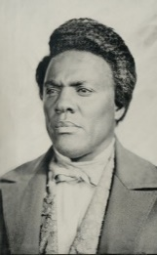
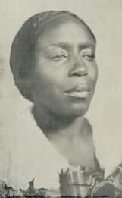
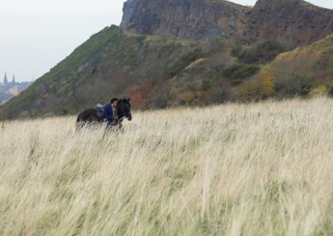
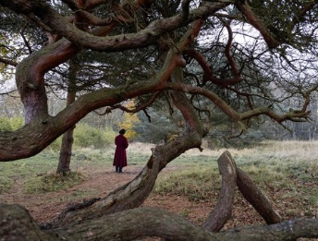
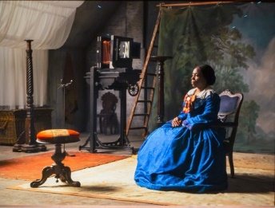
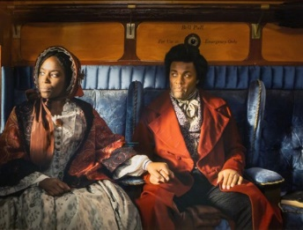
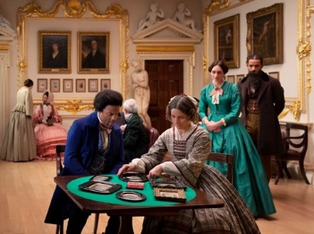
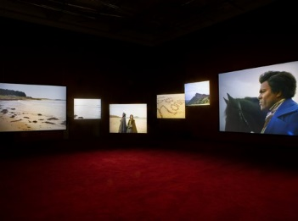
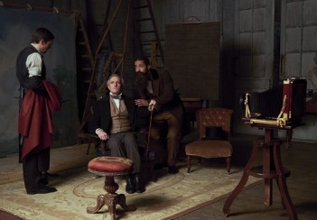
Take a closer look
This activity is designed to encourage conversation. We all see art differently, bringing our own life experiences to how we interpret visual language; there are no right or wrong opinions about art. Please encourage students to express their own views and respect those of others.
Frederick Douglass understood the power of images to change society. He compared
pictures to songs, saying that they should be allowed to speak for themselves.

Choose one image to talk about:
What do you notice? List everything in detail.
How was it made?
Do you think the subject matter was imagined, remembered or directly observed?
What kind of person do you think made it? How does it make you feel and why?
What do you love / hate about it?
What was happening in Scotland at the time it was made?
When / where / why do you think it was created?

TASK 1

All of the images shown here are taken from the installation Lessons of the Hour by Isaac Julien, shown at the Scottish National Gallery of Modern Art in partnership with Edinburgh Art Festival 2021.

How to get to know something that cannot speak?
Activity adapted from a workshop by Tako Taal
TASK

About this activity
Tako Taal’s art practice is concerned with colonial relations and the question of how vivid they remain in the present.
She often starts by having conversations with people. But she says: what happens when
the thing can’t talk back to you because it’s a photograph, a rock or a plant?
In this activity, learners are prompted through questioning to have a conversation with an image to see how that changes their understanding of it.
What happens when the person or thing you want to understand can’t talk back to you?
One way to explore this is to ask questions. Questions help us to imagine other ways of being.

Choose an image from below and get to know it better.
- What do you recognise? What do you not recognise?
- How do you begin a conversation with the image? What do you want to know more about?
- Use these promps to come up with questions: What? Where? When? How? Who? Is?
- Think about what this image asks of you?
- Using your answers create a story about the image either about its history, present or future.

Tako says:
‘Questions help us to imagine other ways of being. In history we learn that there is a timeline and things happen in an order,
one after the other. BUT our minds are very powerful things. They don’t work in the same order - when you think about something that happened a long time ago it is by remembering it - it begins to happen for us now in the present. Also, when we imagine a future, it is also happening now in the present for us. So, by asking questions by speaking to objects
or people from the past we can bring them into our present. We can be with them here and now - in this space. Specifically, I want to think about, how do you speak to something or someone that is not there or can’t reply?’
In 2021 Tako Taal was commissioned by Edinburgh Art Festival to invite artists to respond to the themes of Isaac Julien’s Lessons of the Hour in a programme called What happens to desire… https://www. edinburghartfestival.com/the-festival/ commissions-programme/associate-artist- programme/ Artists included Chizu Anucha, Sequoia Barnes, Francis Dosoo, Thulani Rachia, Camara Taylor and Matthew Arthur Williams.
https://www.takotaal.com/

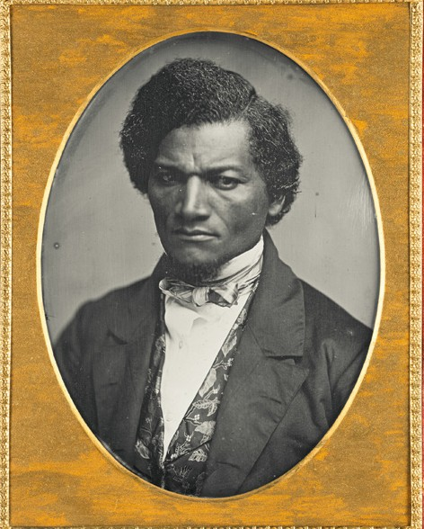
About these images
Historic photos are included here alongside contemporary artworks by Scotland-based artists.
  - Samuel J Miller, Frederick Douglass, 1847-52, digital reproduction of daquerreotype, Art Institute of Chicago Major Acquisitions Centennial Endowment ©Photo: The Art Institute of Chicago / Art Resource, NY/ Scala, Florence
  - Sequoia Barnes, Gateway (installation images), Edinburgh Art Festival 2021. Photo: Sally Jubb Photography.
1
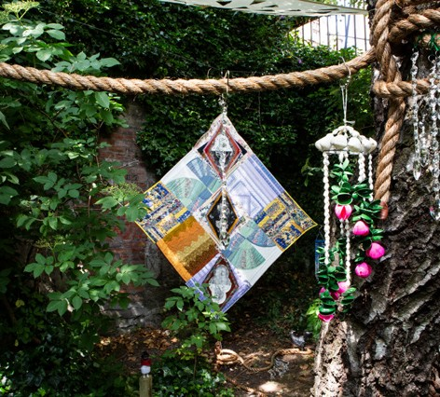
In this textile installation, which is reminiscent of a shrine, Sequoia seeks answers to her questions about the journey of sculptor Edmonia Lewis and Frederick Douglass to Naples in 1887. The exact details of the trip are not documented, leaving room to speculate as to what happened.
Barnes summons the spirits of Lewis and Douglass folding their desires into a quilt made with previously owned textiles. https://sbarnes.me
  - Unknown photographer, Anna Murray Douglass, Photograph first
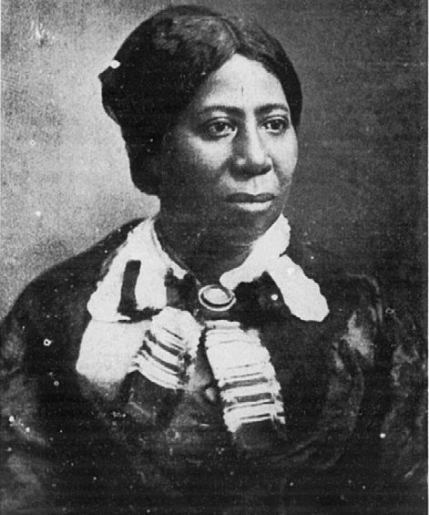
- published in Rosetta Douglass Sprague, “My Mother As I Recall Her”, 1900, Public Domain, via Wikimedia Commons
  - Camara Taylor, Still from holus-bolus
This video is inspired by the life and death of William Davidson (1781– 1820). Conspirator, radical or wrongfully convicted, Davidson was the son of a Scotsman, the Attorney General of Jamaica, and a Black woman. In 1820, Davidson was tried for his alleged involvement in the Cato Street Conspiracy (a radical plot to assassinate cabinet ministers and the Prime Minister). Throughout the trial, Davidson maintained his innocence, claiming he’d been mistaken for another man of colour. https://
- camarataylor.com
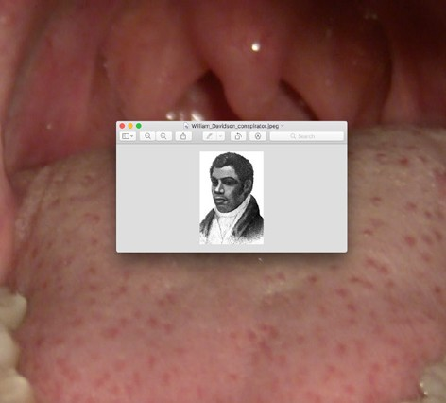
  - Matthew Arthur Williams, In guise of Land
Matthew has photographed himself at various locations on the West coast of Scotland including the Isle of Eigg. He references a long history of portraits in the landscape, specifically the photographers Ajamu X and Ingrid Pollard.
Black and white self-portraits show his body embraced by bracken,
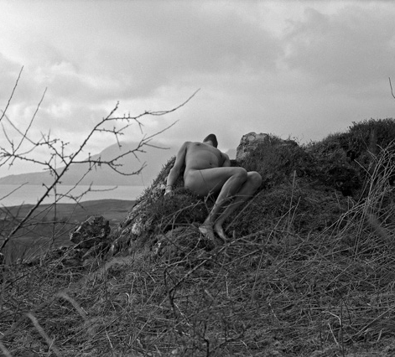
- becoming part of the Scottish landscape. This alters the narrative of what it means for Black and queer bodies to inhabit rural environments. http:// www.matthewarthurwilliams.com

5

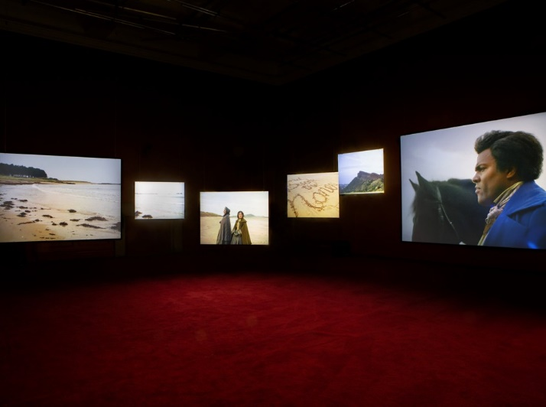
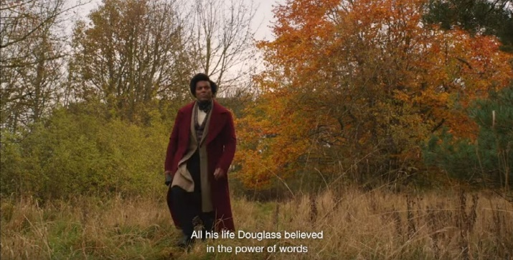
Lessons of the Hour
This activity is deliberately open-ended to encourage students to do their own research and to empower them to have their own voice.
You might prefer to tailor an activity to focus on one specific subject area e.g. art/history/ modern studies. Start by watching this trailer for Lessons of the Hour. https://www.youtube. com/watch?v=vEghwTJPDw0

What do you think are the lessons artist Isaac Julien wants us to learn?
In this short film Isaac talks about:
- the relevance of the past in the future.
- Individually and collectively learning from the past.
- The power of words.
- The murder of George Floyd and Black Lives Matter.
- That we need to learn to become anti- racist as a society and understand Black History, in the context of the transatlantic trade in enslaved Africans, and how despite the abolition of slavery there
is still discrimination against People of Colour today.

TASK 3

Design a lesson for your peers

Decide where, when and how would you deliver your lesson to inspire and inform other people your age. It could be something fun, something practical, political, historical, or cultural.
What things are important now/for future that you think every young person needs to know?
What is missing from what you are taught at school?
Why do you think it is not taught?

Further inspiration
The Anti-Racist Educator offers inspiration in the form of these short essays written by young people in Scotland outlining their own views.
Pupils in Scotland Call for Change: It’s Time for an Anti-Racist Decolonised Curriculum https:// www.theantiracisteducator.com/post/pupils-in- scotland-call-for-change-it-s-time-for-an-anti- racist-decolonised-curriculum
Watch an extended version of the film which gives more insights into Lessons of the Hour here https://www.youtube.com/ watch?v=rLWYRzkWa7k (17mins)

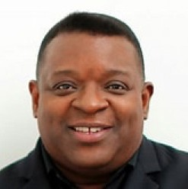
About the artist Isaac Julien
Isaac Julien CBE, RA, is a distinguished installation artist, filmmaker and Professor at UC Santa Cruz. Born is 1960, in London, he is of
Caribbean heritage, from St. Lucia. His multi-screen film installations and photographs focus on the experience of Black identity, including issues of class, sexuality, and artistic and cultural history.
Isaac Julien’s ten-screen film installation Lessons of the Hour is inspired by the life and times of Frederick Douglass, the visionary African American orator, philosopher, intellectual, and self-liberated freedom-fighter, who was born into slavery in Maryland, USA in 1818. From 1845-7, Douglass made repeated visits to Edinburgh, while campaigning across the UK and Ireland against slavery in the USA.
Filmed at sites in Edinburgh, London and Washington DC, Julien’s work is informed by some of Douglass’ most important speeches, including ‘Lessons of the Hour,’ ‘What to the Slave is the 4th of July?’ and ‘Lecture on Pictures’.
Douglass was the most photographed American in the nineteenth century and was very aware of the power of images.
In his 1861 lecture, Douglass expressed his vision of how picture-making and photography could offer powerful tools in the fight for social justice
and equal human rights for all.
https://www.edinburghartfestival.com/event/isaac-julien-lessons-of-the- hour/
http://www.isaacjulien.com
Artist Isaac Julien talks about his life and influences: https://www.moma. org/explore/inside_out/2013/12/19/riot
Celeste Marie Bernier, Judith Butler and Isaac Julien in Conversation about the artwork Lessons of the Hour (1 hour recording) https://www. youtube.com/watch?v=8qi3L8an1Y4

Abolition refers to the legal ending of chattel slavery. In Britain, Parliament ended the transatlantic slave trade in 1807 and British slavery was legally abolished in 1833. In 1837, Parliament passed the Slave Compensation Act, borrowing £20 million to provide compensation to former British slave owners. No compensation was paid to the formerly enslaved people. In the USA slavery continued until 1865.
The British Empire at its height was the largest empire in history, officially lasting from the sixteenth into the nineteenth century. Its territories once covered approximately a quarter of the land on earth, including Afghanistan, Africa, America, Canada, Egypt, India, Iraq, Jamaica, New Zealand, Pakistan, Palestine to name but a few.
Chattel slavery means that one person has total ownership of another. A chattel slave was legally considered to be the property of the slave owner, as were the children of the enslaved.
Colonialism is when a country takes control over another region or country, its people and resources.
Over 60 territories gained independence from the United Kingdom between the eighteenth and twentieth centuries.
Today there are 14 overseas territories, known as the British Overseas Territories, which form the remnants of the British Empire. However, the legacy of empire extends beyond these 14 locations. Aspects of the British language,
culture and legal system can still be found across the world today. Racism, discrimination and other negative consequences can be attributed to the impacts of the British Empire world-wide.
Contemporary art is a term broadly used to describe art that is made now about now. Often confused with Modern art, which means art made between approximately the 1860s and 1970s, when many artists rejected previous traditions and narrative art in favour of new ideas, experimentation and abstraction.
Human rights are the fundamental moral rights that every person is entitled to simply because they are a human being, regardless of their age, race, location, language, religion, ethnicity, or any other protected characteristic.
Intersectionality is when multiple social categorizations such as race, class and gender overlap to create interconnected systems of discrimination or disadvantage.
Manumitted means released from slavery.
Professor Emeritus This is a title given to a retired professor, who has been permitted to retain an honorary title at the rank of the last office held, often as a mark of distinguished service.
Protected characteristics The Equality Act 2010 protects people against discrimination, harassment or victimisation in employment, and as users of private and public services based on nine protected characteristics: age, disability, gender reassignment, marriage and
civil partnership, pregnancy and maternity, race, religion or belief, sex, and sexual orientation.
The transatlantic trade in enslaved Africans was a hugely profitable British business from the sixteenth to the nineteenth century. It involved 3 stages:
- Ships carrying slavers and manufactured goods, such as guns and cloth, sailed from Britain to West Africa.
- The goods were sold in exchange for men, women and children who had been forcibly taken from their villages. These people were transported across the Atlantic, in atrocious conditions, with many dying onboard.
They were taken to various locations in the Americas, many to the Caribbean and Brazil, where they were forced to work on sugar and cotton plantations, as well as in other enslaved roles. Numbers are unconfirmed but approximately 12-15 million Africans were enslaved and a similar number died during capture or transportation.
- The third stage was the transportation of goods produced by the enslaved, such as sugar and cotton, back to Britain.
The Underground Railroad was a network of secret routes and safe houses set up in the USA during the early to mid-nineteenth century to help enslaved African Americans to escape into Canada and American states which had already abolished slavery.

About Scotland’s role in chattel slavery
https://www.nls.uk/collections/topics/slavery/
African American Activists in Scotland: https:// digital.nls.uk/learning/struggles-for-liberty/ themes/african-american-activists-in-scotland/

About Frederick Douglass
This podcast gives a brief overview of Frederick Douglass’s political life: https://www. talkingpoliticspodcast.com/history-of-ideas- series-two
Find out more about Frederick Douglass’s use of autobiography: https://www.nls.uk/ exhibitions/treasures/frederick-douglass/ autobiography/
NLS maps, Frederick Douglass in Scotland https://geo.nls.uk/maps/douglass/scotland. html

Education and inspiration
Award-winning musicians Young Fathers made a short video in the Scottish National Portrait Gallery which explores the links between historic portrait painting and white privilege https://www.youtube.com/watch?v=XkSSj5HcCV0
The World Reimagined is a ground-breaking, national art education project to transform how we understand the transatlantic trade in enslaved Africans and its impact on all of us: https://www.theworldreimagined.org/
The Anti-Racist Educator https://www.theantiracisteducator.com/
RACE.ED showcases excellence in teaching, research and knowledge exchange in race and decolonial studies at The University of Edinburgh: https://www.race.ed.ac.uk/
UncoverEd is a collaborative student-led archival project at the University of Edinburgh. The team works on uncovering the University’s role in the imperial project and addressing that colonial legacy: http://uncover-ed.org/
Find out about early photography https://www. nationalgalleries.org/art-and-artists/features/ early-photography

Support Organisations
SCOREscotland is a social justice organisation based in Wester Hailes, delivering a range of services in West/South West Edinburgh https://www.scorescotland.org.uk/
Intercultural Youth Scotland is Scotland’s leading charity for Black and People of Colour youth https://interculturalyouthscotland.org/

edinburghartfestival.com nationalgalleries.org

